Rotary Club of Gyaneswor
Service Project Report for the month of August

Title (4-7 Words): | Support to Animal Welfare Initiative
Club Name: | Rotary Club of Gyaneswor, Club no 223163
Event Date: | 1st August – 31st August 2025
News (100-250words)  - Specialty  - Facts & Figures  - Budget  - Beneficiary Profile  - Impact/Outcome | - On August 1st, the Rotary Club of Gyaneswor provided financial assistance of NPR 20,000 to the volunteering organization "असहाय गाईबाछा संरक्षण अभियान", based in Gothatar, Kathmandu.  - This organization has been actively rescuing abandoned cows and calves found on the streets, offering them shelter, food, and clean drinking water. The donation will support their ongoing efforts to care for these helpless animals and ensure their well-being.  - Rotary Club of Gyaneswor remains committed to supporting initiatives that promote compassion, service, and positive change in our community.

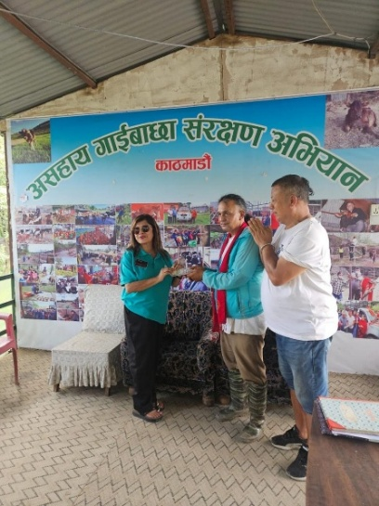
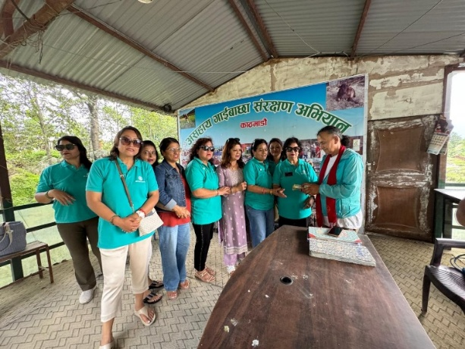
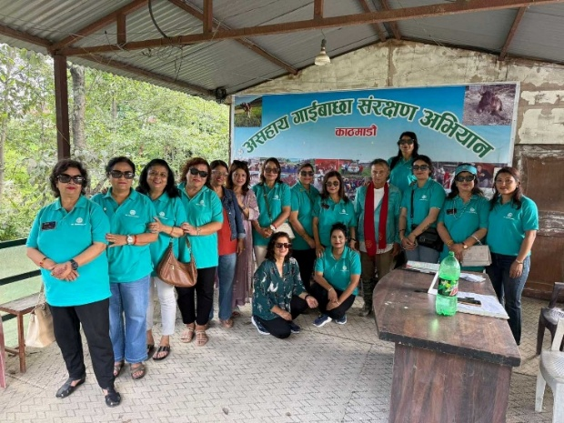
Photos: असहाय गाईबाछा संरक्षण अभियान
Written by: Service Project Chair, Rtn Pragya Pandey Gyawali
Checked & approved by: President, Rtn Sangeeta Sharma Dwivedi
Submitted by: Secretary, Rtn Sonu Dangol
Date: 5th September, 2025

